Meter Fraud Detection Using Machine Learning: A Case Study in South Africa
Authors: Simanga Mchunu , Nkosinathi Nhlapo , Kagiso Leboka, Bongani Baloyi
Mentors: Ajit Samuel John, Saurabh Srivastava

Abstract
Meter fraud and electricity theft pose significant financial and operational challenges for utility providers. Fraudulent activities such as meter tampering and illegal connections lead to substantial revenue losses and an increased burden on legitimate consumers. This study leverages machine learning techniques, including Isolation Forest, Random Forest, and XGBoost, to identify anomalies in energy consumption patterns. The findings highlight that XGBoost provides superior accuracy in detecting fraudulent behavior. The study also incorporates geospatial mapping and trend analysis to enhance fraud detection efforts. This research contributes to the ongoing efforts to mitigate electricity theft using AI-driven solutions. The project was supported by IBM Z and LinuxONE machines and was made possible through collaboration with the Shooting Stars Foundation and dedicated mentors.

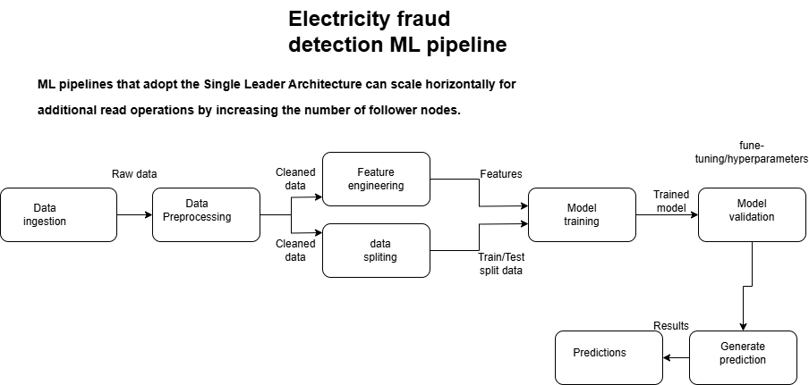

1. Introduction
Electricity theft remains a significant issue in South Africa, leading to billions of rands in annual losses. Fraudulent consumers manipulate their smart meters to reduce their bill amounts, negatively impacting utility providers and honest customers. Traditional fraud detection methods rely on manual inspections and rule-based systems, which are inefficient and prone to human error. This study proposes an automated, machine-learning-based approach to detecting fraudulent energy consumption patterns.

2. Problem Statement

Electricity theft in South Africa poses a significant challenge to utility providers, resulting in substantial economic losses, estimated at approximately R20 billion annually (Netwerk24, 2024), (Mujuzi, 2020). According to the article by Jamil Ddamulira Mujuzi, the leading cause of blackouts in South Africa is primarily due to collapsing Eskom infrastructure as a result of illegal connections. Figure 1 emphasizes the increase in load-shedding hours over the years, indicating the impact of degrading Eskom infrastructures possibly due to illegal connections
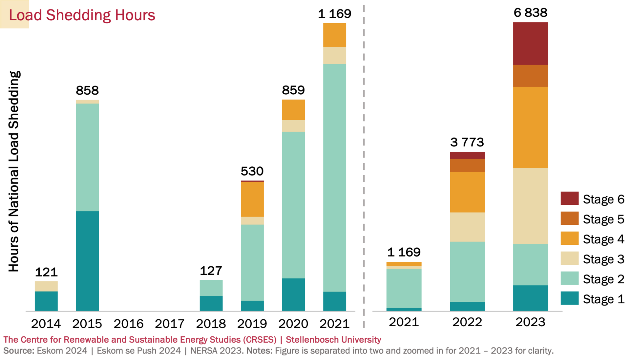

Figure 1: Loeadshedding Trend by hour by stages (Wikipedia, South African Energy Crisis 2025)

Traditional manual detection methods are proving increasingly ineffective and time-consuming in combating this pervasive issue. This necessitates the exploration and implementation of automated, AI-driven solutions capable of real-time anomaly detection and prevention to mitigate the escalating financial burden and ensure the sustainable provision of electricity services.

3. Data Collection & Preprocessing

Dataset Features
The dataset includes:
- Customer Data: Meter ID, Timestamp, Province, City, GPS Coordinates
- Energy Metrics: Energy Consumption (kWh), Solar Generation (kWh), Voltage, Frequency, Power Factor
- Fraud Label: Binary classification (Fraud/No Fraud)
- Load Shedding Impact Considered
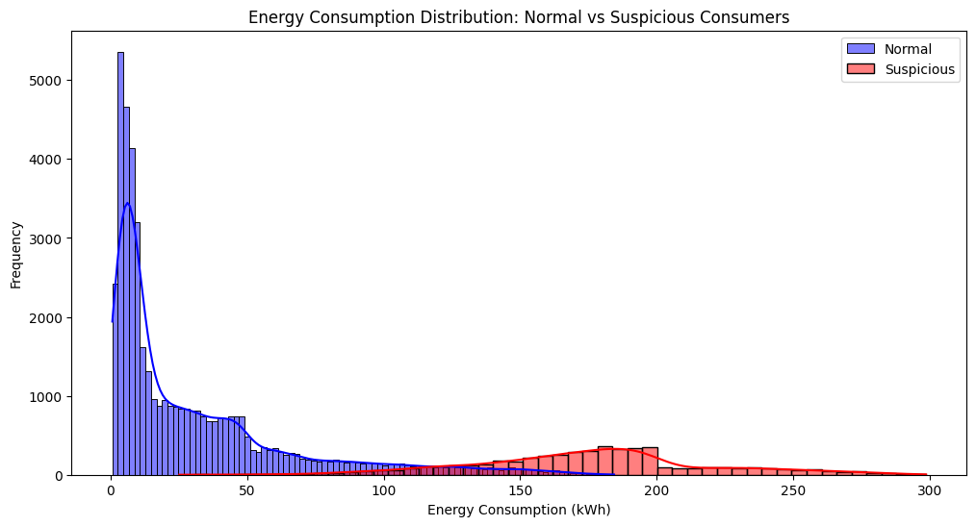

Preprocessing Steps
- Timestamp Conversion: Extract hour, day, month, and weekday for trend analysis.
- Feature Engineering: Calculate power efficiency and energy consumption per voltage.
- Scaling & Normalization: Standardize features for improved machine learning performance.
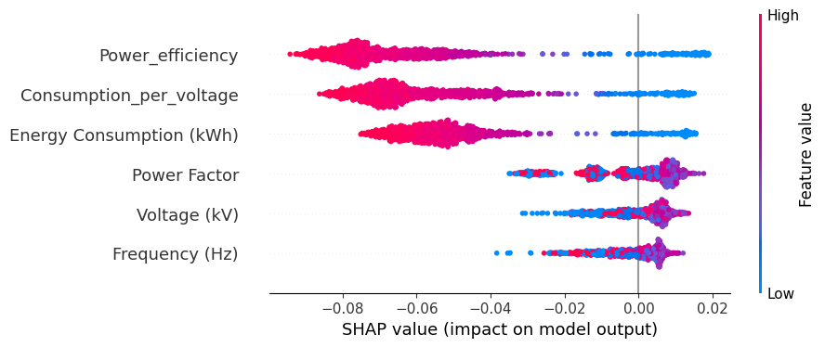

4. Machine Learning Models & Evaluation

Implemented Models:
- Isolation Forest: An unsupervised anomaly detection model.
- Random Forest: A robust supervised classification algorithm.
- XGBoost: A gradient-boosting algorithm that excels in fraud detection.
- Logistic Regression: A baseline model for comparison.

Performance Metrics
Model | Accuracy | Precision | Recall | F1-Score | ROC-AUC
XGBoost | 98% | 93% | 88% | 90% | 97%
Random Forest | 96% | 89% | 82% | 85% | 94%
Isolation Forest | 88% | 70% | 91% | 79% | 90%
Logistic Reg. | 92% | 85% | 79% | 82% | 92%

Best Model:
XGBoost achieved the highest accuracy and recall, making it the best choice for fraud detection.

5. Isolation Forest: Theory and Application

Understanding Isolation Forest
Isolation Forest is an unsupervised anomaly detection algorithm based on the concept of Isolation Trees (iTrees). The key concepts include:
- Isolation Trees: The dataset is recursively partitioned by randomly selecting features and splitting points.
- Anomaly Score: The number of splits required to isolate a data point determines its anomaly score. Lower splits indicate higher likelihood of fraud.
- From iTree to Isolation Forest: Multiple isolation trees aggregate results to improve detection accuracy.
In this study, Isolation Forest helps identify fraudulent users by isolating anomalous energy consumption patterns.
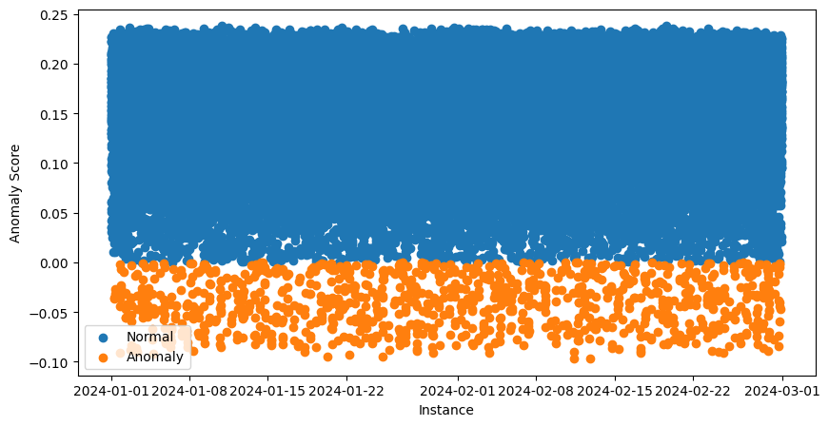
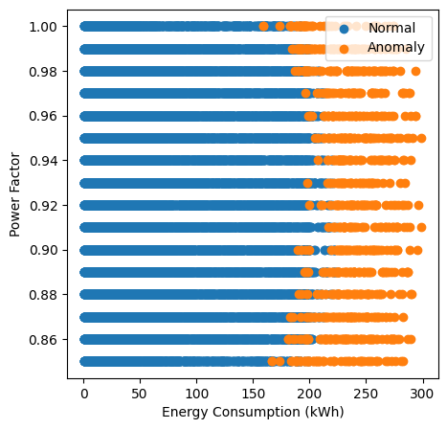

6. Results & Insights

Trend Analysis
- Fraudulent activities peak between 12 AM - 5 AM, indicating suspicious behavior.
- Fraudsters exhibit sudden drops in consumption, suggesting meter tampering.
- High-risk 5 cities include Johannesburg, Cape Town, and Durban, Bloemfontein, Polokwane.
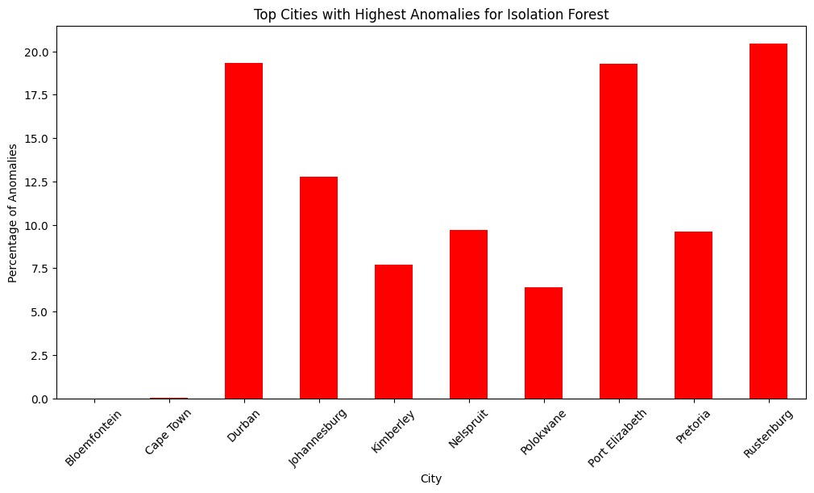

Geospatial Fraud Mapping
- Used GeoPandas & Shapefiles to visualize fraud hotspots.
- High-risk areas were mapped, enabling targeted inspections.
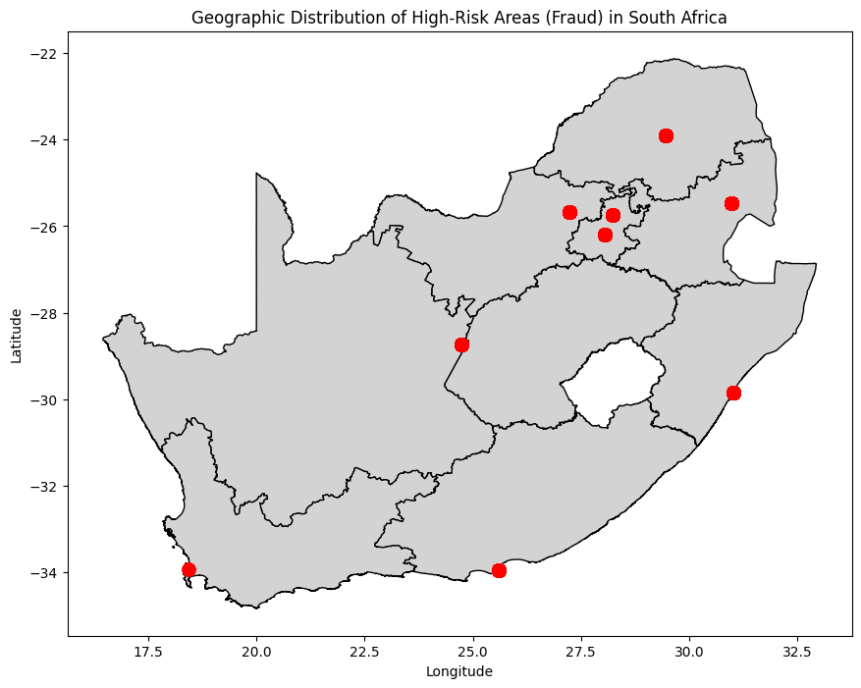

7. Actionable Recommendations

For Utility Companies
- Deploy XGBoost-based fraud detection models for real-time monitoring.
- Increase meter inspections in high-risk areas.
- Implement automated alerts for anomaly detection.

For Policy Makers
- Strengthen laws against electricity theft (BusinessTech, 2024).
- Introduce stricter penalties for fraudsters.

For Consumers
- Raise awareness about the risks of illegal connections.
- Provide incentives for legal energy use and solar adoption.

8. Conclusion & Future Work

Conclusion:
This study demonstrates that machine learning can effectively detect fraud in smart meters. XGBoost outperformed other models and can be deployed for real-time monitoring.

Future Work:
- Develop a real-time fraud detection API (FastAPI).
- Integrate deep learning models (LSTMs, ) for advanced pattern recognition.
- IoT integration with smart meters for proactive fraud prevention.

Acknowledgments
This research was made possible through support from IBM Z, LinuxONE machines, and the Shooting Stars Foundation. We extend our gratitude to our mentors for their invaluable guidance throughout this project.

References
- Netwerk24 (2024). Meter Tampering: The Facts. Netwerk24. Available at: https://www.netwerk24.com/netwerk24/za/weskusnuus/nuus/meter-tampering-the-facts-20240909-2 [Accessed 9 Mar. 2025].
- BusinessTech (2024). D-Day for Electricity Theft in South Africa. BusinessTech. Available at: https://businesstech.co.za/news/energy/800437/d-day-coming-for-south-africans-stealing-electricity/ [Accessed 9 Mar. 2025].
- Council for Scientific and Industrial Research (CSIR) (2024). CSIR Releases Statistics on Power Generation in South Africa. CSIR. Available at: https://www.csir.co.za/csir-releases-statistics-on-power-generation-south-africa-2024 [Accessed 9 Mar. 2025].
- Cape Business News (CBN) (2024). The Growing Threat of Electricity Meter Tampering in South Africa: A Call for Smart Solutions. CBN. Available at: https://www.cbn.co.za/featured/the-growing-threat-of-electricity-meter-tampering-in-south-africa-a-call-for-smart-solutions/ [Accessed 9 Mar. 2025].
- Liu, F. T., Ting, K. M., and Zhou, Z. H. (2022). Isolation-Based Anomaly Detection. arXiv. Available at: https://arxiv.org/abs/2206.06602 [Accessed 9 Mar. 2025].
- South African Energy Crisis (2025) Wikipedia. Available at: https://en.wikipedia.org/wiki/South_African_energy_crisis (Accessed: 25 March 2025).
- Mujuzi, J.D. (2020) Electricity theft in South Africa: Examining the need to clarify the offence and pursue private prosecution?, Obiter. Available at: https://www.scielo.org.za/scielo.php?script=sci_arttext&pid=S1682-58532020000100005 (Accessed: 25 March 2025).

